

|  |
| --- |
| Capstone Project Document |

**BOOKAHOLIC SOCIAL NETWORK**

Report #1 – Project Introduction

|  |  |  |
| --- | --- | --- |
| **Bookaholic Social Network** | | |
| **Group Members** | Phạm Thị Huyền | SE03416 |
| Thái Thị Cẩm Vân | SE03409 |
| Vũ Hải Đăng | SE03380 |
| Nguyễn Thị Hải Yến | SE03171 |
| Chu Minh Hải | SE03143 |
| **Supervisor** | Mr. Nguyễn Văn Sang | |
| **Project code** | BSN | |

**- Hanoi, 09/2016 -**

# SIGNATURE PAGE

AUTHOR: Phạm Thị Huyền 12/09/2016

Project manager

REVIEWERS: Thái Thị Cẩm Vân 13/09/2016

Team member

APPROVAL: Nguyễn Văn Sang --/--/--16

Supervisor

Record of change

*A - Added M - Modified D – Deleted

|  |  |  |  |  |  |
| --- | --- | --- | --- | --- | --- |
| Effective Date | Changed Item | A,M,D | Change Description | Reason for Change | Rev. Number |
| 12/Sep/2016 | Create Introduction | A | Create Introduction | First version | 1.0 |
| 16/Sep/2016 | Update Comment | M | Update comments of supervisor |  | 1.1 |
| 03/Dec/2016 | Update | M | Update after self-review | Self-review all documents | 1.2 |

Table of Contents

SIGNATURE PAGE 2

1 INTRODUCTION 4

1.1 Purpose 4

1.2 Acronyms and Definitions 4

2 ABSTRACT 4

3 LITERATURE REVIEW 4

4 PROPOSAL 7

4.1 The idea 7

4.2 Objectives 7

4.3 Brief description about system 7

4.4 System features 8

4.4.1 Reader/Author features 8

4.4.2 Admin features 9

5 BENEFIT FROM PROJECT 10

5.1 For our group 10

5.2 For Community 10

6 CRITICAL ASSUMPTION AND CONSTRAINTS 10

7 POTENTIAL RISKS 11

8 REFERENCES 11

# INTRODUCTION

## Purpose

This document is created as the introduction for project Bookaholic Social Network – our Capstone Project at FPT University. In this document, we will descript the overview of some existing systems, the initial idea for our project, a brief description about our expected system and some potential risks, critical assumptions, constrains. Moreover, this document also shows opportunities what it offers for users.

## Acronyms and Definitions

|  |  |  |
| --- | --- | --- |
| Acronym & Abbreviation | Definition | Note |
| BSN | Bookaholic Social Network |  |
| FU | FPT University |  |

**Table 1-1:** Definitions and Acronyms

# ABSTRACT

Nowadays, social network plays an essential role in our lives. Vietnam is the country that has the big Internet user growth and the trend of communication through social network is expanding rapidly, people shares and discuses about everything through social network. However, there is not any social network that is for only Vietnamese people who love reading books. To solve this problem, we create a website where people who loves book can share and discus with others about their favorite books or authors. We believe this project will strengthen Vietnam’s reading culture.

# LITERATURE REVIEW

There are some social networks about book. For example: Goodreads, Shelrafi, Wattpad, etc. However, there is not any social network about books for Vietnamese only.

* **Goodreads**

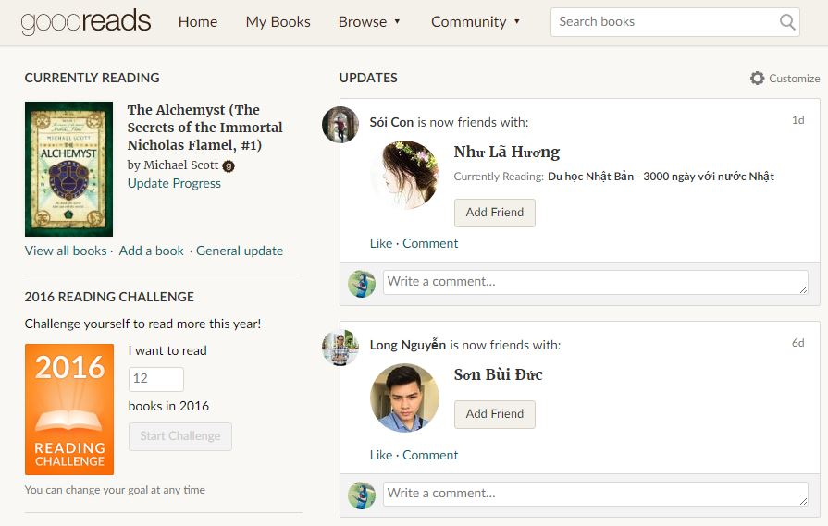

Figure 1-1: Website Goodreads

Goodreads is a platform that allows members to recommend books, create connection with other members or follow a club to keep track of what they’ve read and would like to read.

* **Advantages:**

Goodreads launched in January 2007. It is the world’s largest site for readers and book recommendations with 50 million members, 1.5 billion books and 50 million reviews. Therefore, if you use Goodreads to its full potential, you'll find a robust community of book lovers and a nearly endless list of recommendations. Goodreads also allows users to join conversations about their favorite books or authors. Moreover, it lets you organize your personal collection of books and keep track of what you look for gaps within you collection.

* **Disadvantages:**

It has no real filter between kid and adult content. While 13 is the recommended age for signing up, there's nothing stopping a teen from joining groups which is about adult content. Teens should be cautious about what they share and use privacy settings to minimize contact with strangers.

* **Wattpad**



Figure 1-2: Website Wattpad

Wattpad is a platform that authors and publishers use for online engagement and to create purposeful relationships with readers.

* **Advantages:**

Wattpad is user friendly, so it has a huge number of audiences. Therefore, when you publish something on Wattpad, you can build a fan base as well as a timestamp through which you can prove your original copyright. Wattpad allows authors to share their work with the world and easily interact with their fan.

* **Disadvantages:**

However, Wattpad usually recommends to users about things they do not really need. It’s annoying when the main page is all reading lists, recommendations that users do not really care about, especially with authors. Moreover, the writing feature is not well supported such as all the tools are hidden until you highlight something and then they pop up over the text.

# PROPOSAL

## The idea

Nowadays, as the negative side of social media, teens are not often reading books, especially traditional books. In Vietnam, almost people prefer to spend time for web surfing than read a paper books. Our idea is creating a website that allows people to share and talk about books they would like to read or authors they are interested in. This project aims to make more fun in reading to encourage people especially teens to read more.

## Objectives

This project is the Capstone Project in FPT University studying program. Firstly, this project is responsibility for all team members. Therefore, we must complete all requirements from teacher and FU. During the time doing project, we can learn how to develop a project, how to manage project, how to communicate better between team members, how to control time and how to perform teamwork effectively. Moreover, we will also have experience in .NET technology, website designing and software testing. Therefore, we think this project is very necessary for us to improve skills, knowledge which we studied in FU. Moreover, this project also makes our CV more attractive after graduating from FU. This is also an opportunity for us to prove capacity with recruiters.

Secondly, we all know that it is worth reading books. We believe this project will strengthen Vietnam’s reading culture. Specially, our website displays completely in Vietnamese, so users can use functions easily, even though they do not know English.

## Brief description about system

This software is a platform for social reading with friendly and attractive interface to make people more interested in reading. Members can share and discus about books. They can also send request to admin to add new books or report about copyright problem. BSN uses familiar technologies as: Bootstraps, .NET MVC5, etc. We are planning to develop a mobile version for easily connecting.

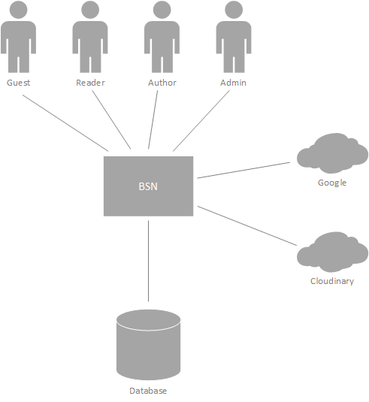

Figure 1-3: Brief description diagram of BNS

## System features

About the features of BSN, we focus to provide for users main features as searching, recommend, discus about books, etc. Admin can manage members, database and manage the development of website through our statistic.

The detailed features are below.

### Guest features

* Guests can register for an account to use features of our system.

### Reader/Author features

* Manage account: Our website allows users to register for an account. Then they can login and use lots of features. Users can edit their profile such as name, date of birth, avatar and cover photo. In case users forget their password, they can send request and system will send them an auto mail to confirm new password.
* Manage recommendation: One of our website’s main features is posting recommendation about books or authors. Users will tag name of book(s) in their post and they can also edit or delete all these content latter. Our site aims to support users interact with others, so they can comment on a post and edit or delete that comment in need.
* Manage interactions: Users of BSN can interact with others by following them.

Moreover, there are several groups about books or authors and users can request to admin of a group to be its members. If users see a group is not appropriate with them or they do not want to join a group anymore, they can remove themselves from that group

Another feature is reporting. Users can report other accounts or groups if those accounts and groups have invalid content or copyright infringement.

* Manage groups: We allow users to create their own group. All groups have to be tagged a book or author as its topic. Admins of a group can add new members to their group by entering their name or accept join-group request.

To manage group members, admins can set other members admin or remove members out of their group

Moreover, admin of a group can edit group information as name, cover photo, etc. and they can also delete a group by removing all its members.

All members can create posts in a group.

* Search and Rate: User can search for books, authors or other accounts. They can also rate for books. Through users’ vote about books and their following authors, our system will calculate and suggest books or authors they may also like.

### Admin features

* Manage user account: To manage user accounts, system admin can search for users and view their profile, posts, etc. After that, they can de-active, active or delete accounts within reporting about those accounts. Moreover, request about creating author accounts will be approved or declined by admins.
* Manage slides: Slides are pictures showed off to help guests preview about our website. Admins will add new slides if need. Depend on situations, admins can de-active, active or delete unnecessary slides.
* Manage publishers: Admins are allowed to add new, update information or delete a publisher.
* View statistic: Manage the development of website if necessary. Therefore, we support admins to view statistic about users, authors or group such as number of accounts, books or authors which is hot trend in that time, etc.

# BENEFIT FROM PROJECT

## For our group

After developing and implementing this project, our group will get some benefits. Firstly, all members will have more experiences of software project management how to manage plan, time, member and risk. Moreover, we will get more knowledge and skill about .NET MVC5, Bootstrap and other skills about real-time programming. The most important benefit is members can improve their skill about communicating with team members and doing teamwork more effective.

## For Community

Just need to have a device that can connect to the internet and any web browser, user can easily join a community about books. They can share, discus with others about their favorite books or authors and update information about new books and trend of reading quickly. They can also find friends who have the same reading hobbit like them. All these things will make reading become more fun and attractive.

# CRITICAL ASSUMPTION AND CONSTRAINTS

* **Critical assumption:**

There are some critical assumptions about training that must be true in real. It is almost members of our team just have basic knowledge about C# asp.Net. We do not have experience in C# asp.Net MVC5, html, CSS, etc. About human resources, we assume that all members in team have a good healthy to do their tasks.

* **Constraints:**

To have good working result, all members must follow some constraints. At first, about time and deadline: We must complete task on time. Our project runs for 14 weeks. Each member works 5 hours/day and 5 days/week. We do not have much time to complete developing and deliver application. Besides, we have to submit report documents before deadline to review. Secondly, about quality of product, it must be run well when users perform main functions in Google Chrome 4.0 or higher. About human resources, our team has 5 members, each member have to study 2 subjects (JPS and JIT) at school. The schedule will base on this and members have responsibility to join meeting and finish tasks on time.

# POTENTIAL RISKS

After studying about this project, we find out some problem that we may be encountered. Firstly, project may be under-estimate scope and time or miss deadline because lack of experience in group working, managing and controlling work. Secondly, it may loss data, source code before uploading data to server because of careless. Moreover, about human resources, team member cannot complete their works because of health reasons, key member leave team or un-cooperating on team. Another risk is changing requirements, requirement changed when some functions cannot be completed or some technologies are not suitable.

# REFERENCES

* Goodread at URL: <https://www.goodreads.com>
* Wattpad at URL: <https://www.wattpad.com>